Lab Report 11

ESE – 3014

EMBEDDED SYSTEMS COMMUNICATION PROTOCOLS AND SECURITY

Submitted to :

Linchen Wang

Submitted by:

Gurvinder Singh(748418)

1. Test your UART on BBB by loopback TXD and RXD as our slides.

2. Set up and achieve UART interfacing communication between BBB and Arduino. You can write a program to control the on-board LED of Ar-duino input and response the feedback as output.

3. your BBB should control your Arduino on-board LED, and change its flashing frequency.

4. Please record each step in your lab report, and I will mark your report based on your step. So you do not have to worry if you can not achieve the final output. And as always, you can take a short video with your experiment output, and append the link in you lab report.

Solution:

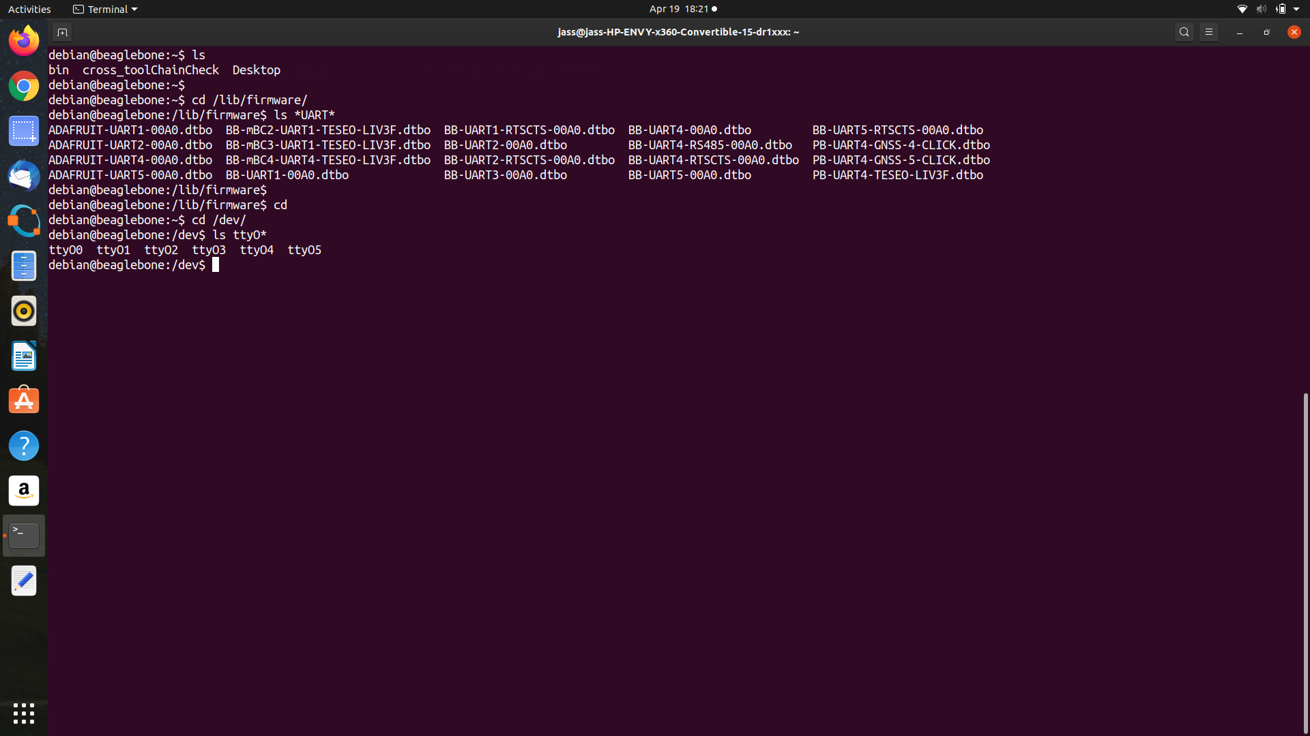

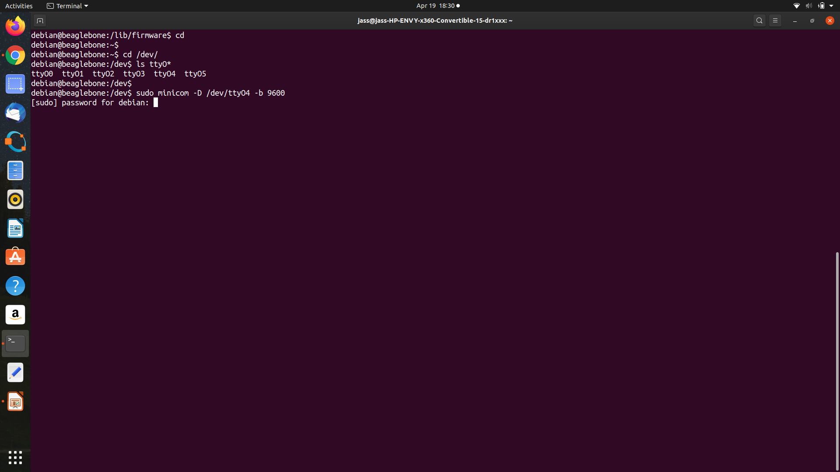

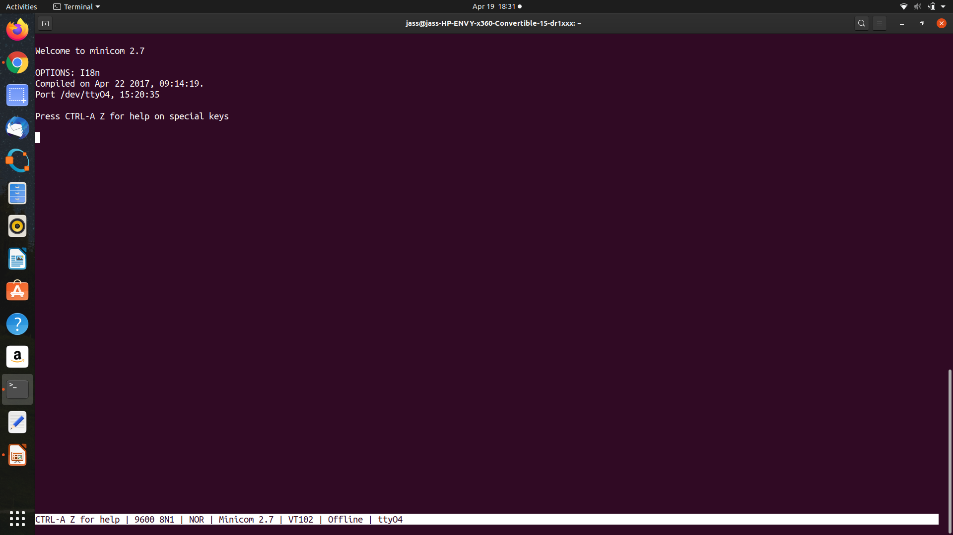

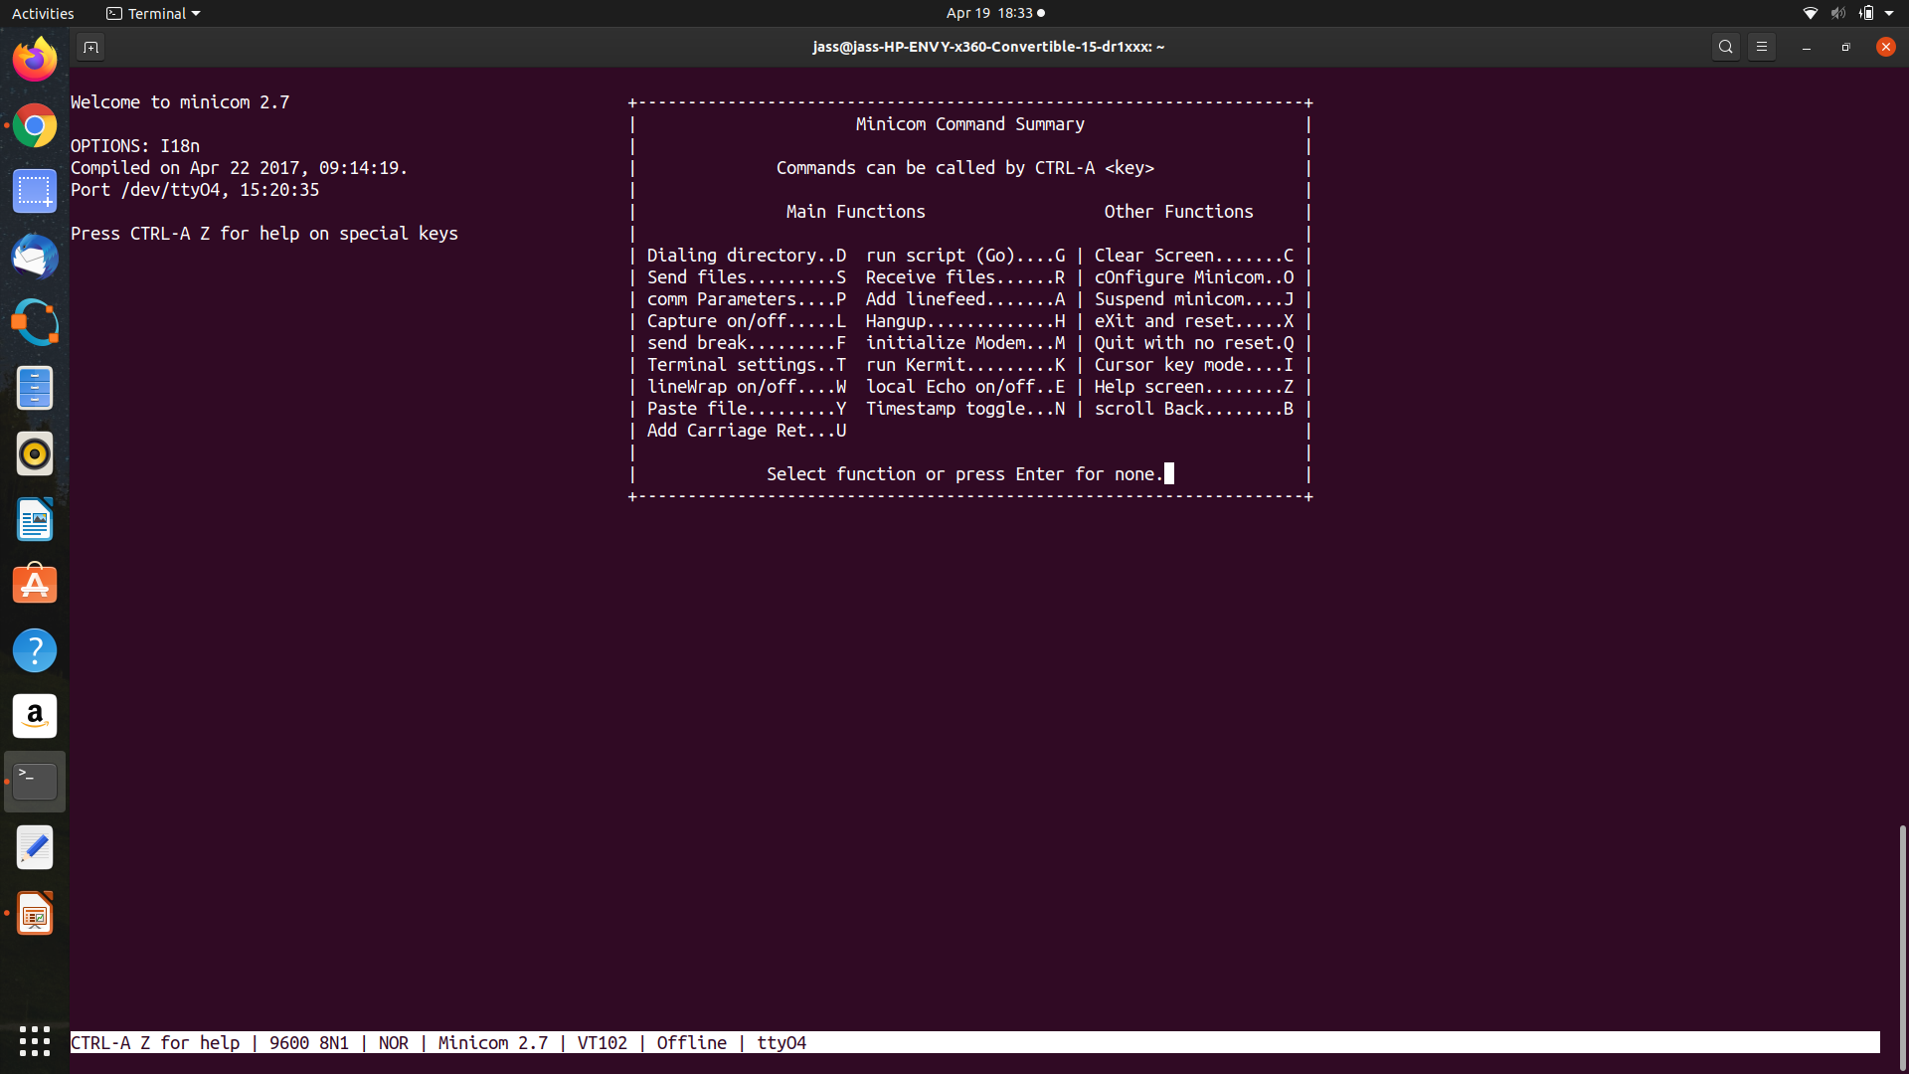

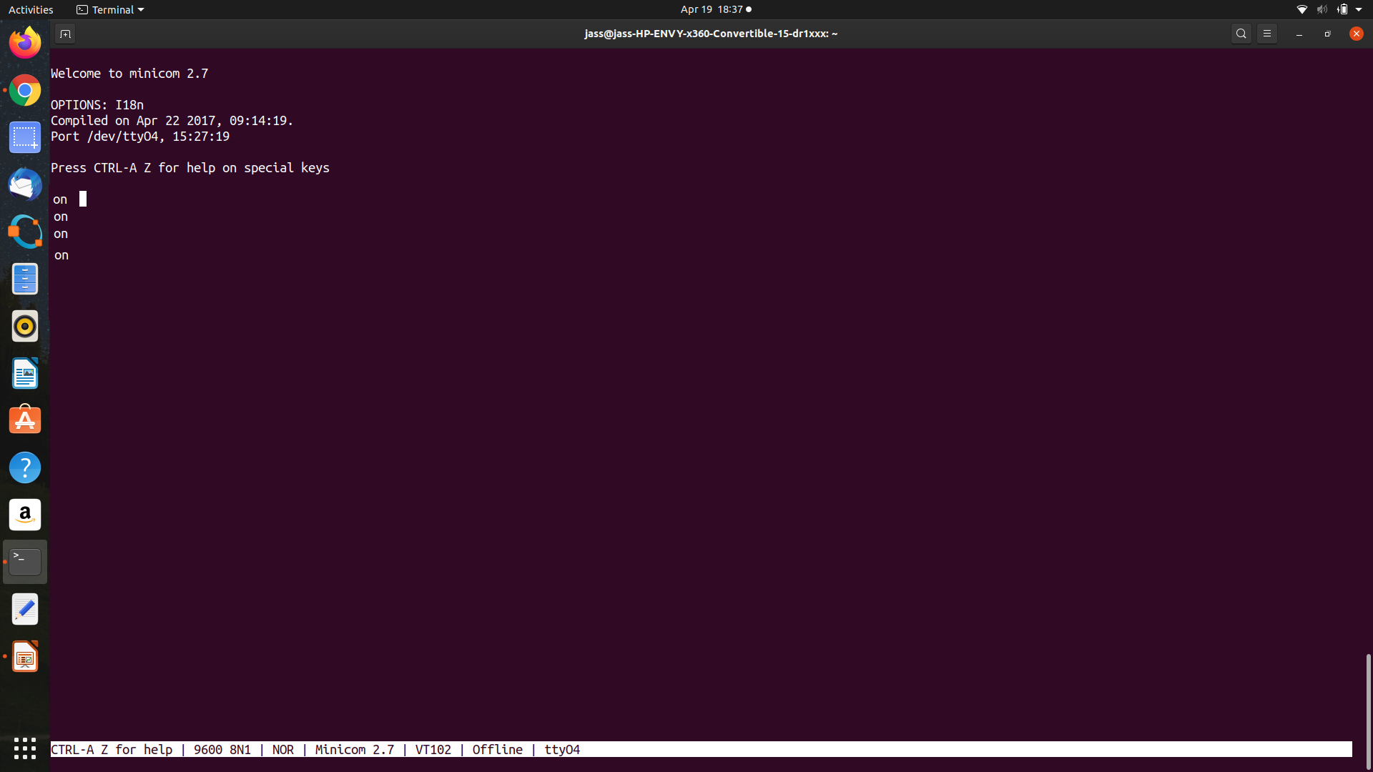

Physical Connections :

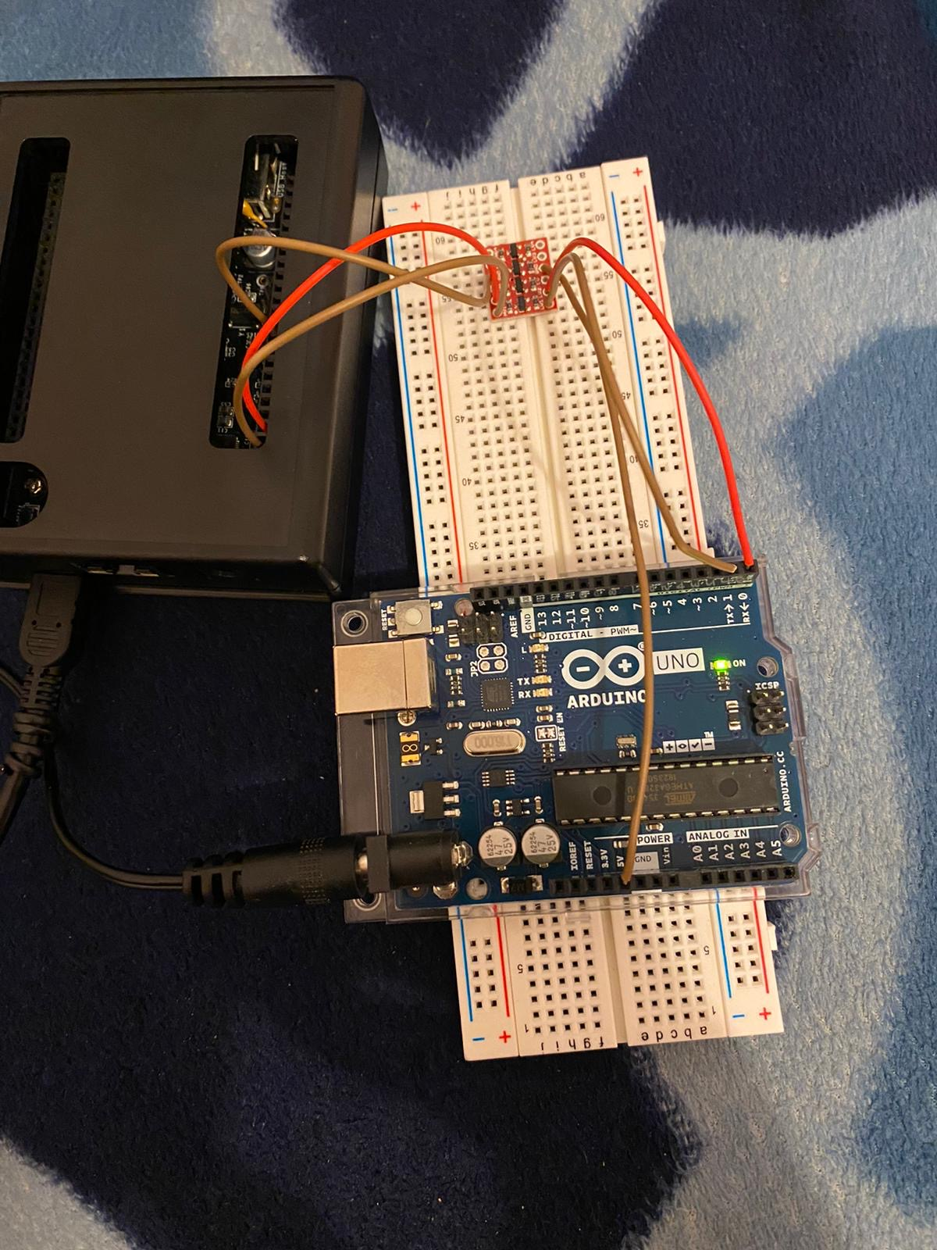

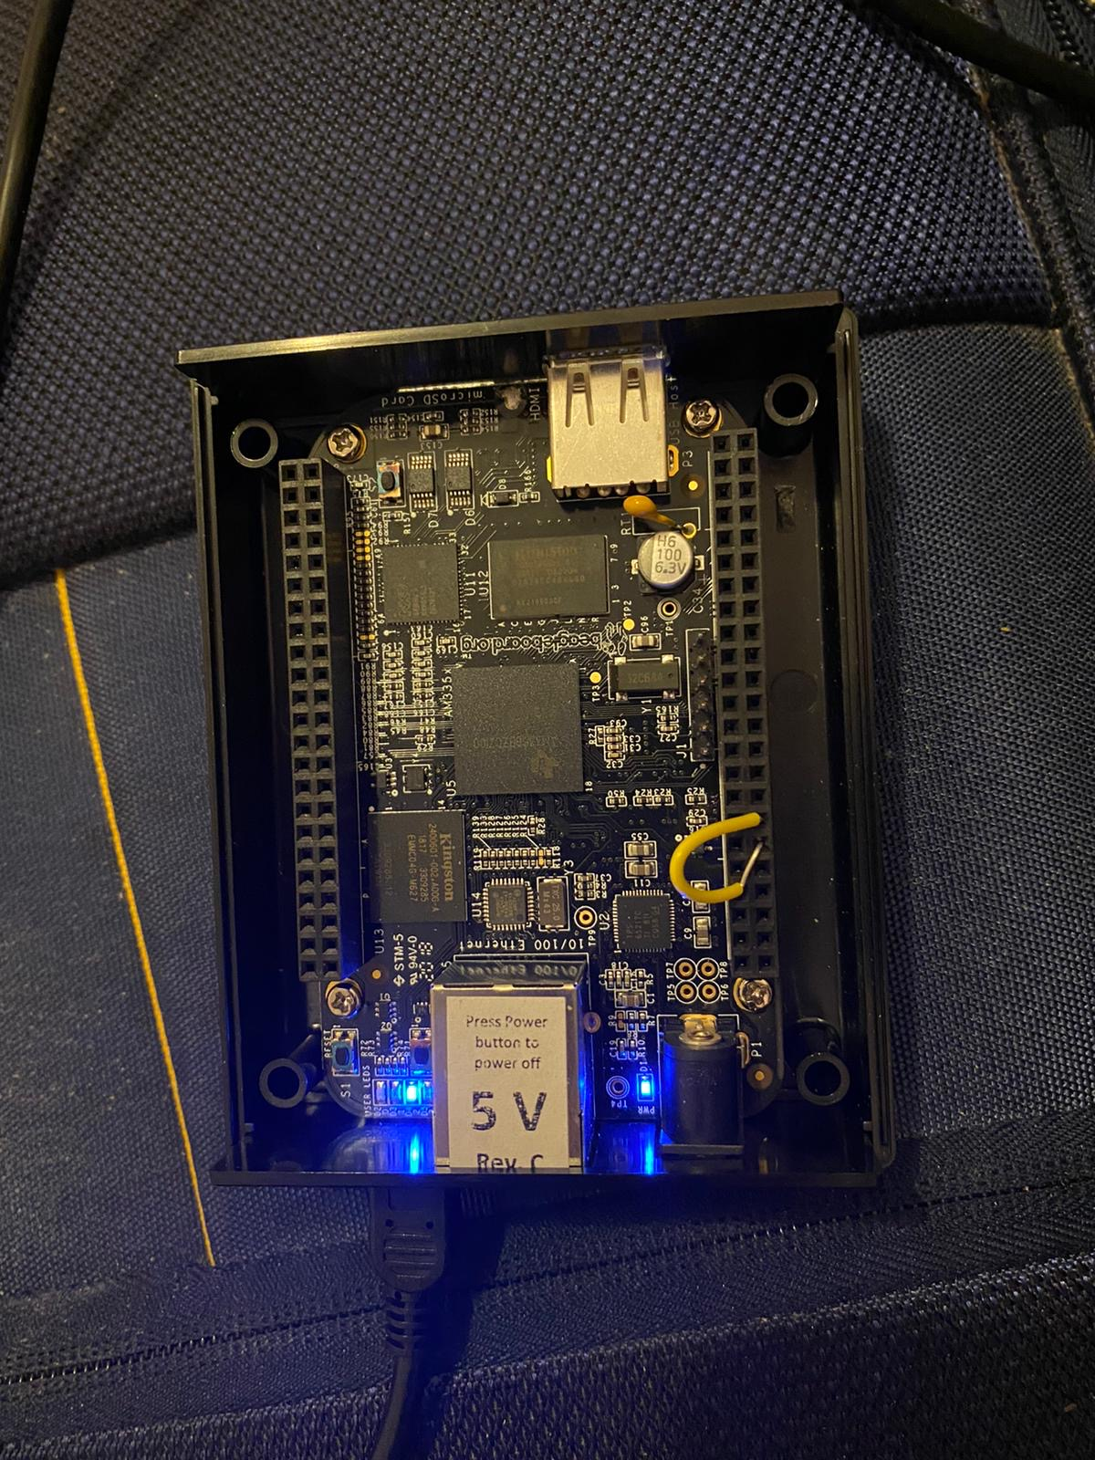

Diagram Provided in PPT:

